Bradley Rwafa ST10458380 References

Static Method In Java Tutorial #76. 2023. YouTube video, added by Alex Lee. [Online]. Available at: <https://www.youtube.com/watch?v=xKZ3sMimQYM> [Accessed 5 Apr. 2024].

Global Variable In Java - How To Use Global Variables In Java. 2019. YouTube video, added by Alex Lee. [Online]. Available at: <https://www.youtube.com/watch?v=retJEPRJeZA> [Accessed 5 Apr. 2024].

Object-Oriented Programming Java Tutorial (Java OOP). 2019. YouTube video, added by Alex Lee. [Online]. Available at: <https://www.youtube.com/watch?v=j0lBrYSlYaU> [Accessed 5 Apr. 2024].

Boolean Java Tutorial #15. 2019. YouTube video, added by Alex Lee. [Online]. Available at: <https://www.youtube.com/watch?v=CHVVEGRGiJU> [Accessed 5 Apr. 2024].

While Loop Java Tutorial. 2019. YouTube video, added by Alex Lee. [Online]. Available at: <https://www.youtube.com/watch?v=SGJ9DpxGCkY> [Accessed 5 Apr. 2024].

Iielearn.ac.za. (2024). Available at: https://myiiemsa.iielearn.ac.za/webapps/blackboard/content/listContent.jsp?course_id=_205844_1&content_id=_20223067_1 [Accessed 10 Apr. 2024]

Java Tutorial for Beginners [Complete Course]. 2019. YouTube video, added by Programming With Mosh. [Online]. Available at: <https://www.youtube.com/watch?v=eIrMbAQSU34&t=3886s&pp=ygUQamF2YSBmdWxsIGNvdXJzZQ%3D%3D> [Accessed 7 Apr. 2024].

Access Modifiers Java Tutorial #82. 2019. YouTube video, added by Alex Lee. [Online]. Available at: <https://youtu.be/H0OetoieSDQ> [Accessed 4 Apr. 2024].

‌

www.javatpoint.com. (n.d.). *Java Regex | Regular Expression - javatpoint*. [online] Available at: https://www.javatpoint.com/java-regex. [Accessed 5 Apr. 2024].

Baeldung (2024). *A Guide To Java Regular Expressions API*. [online] Baeldung. Available at: https://www.baeldung.com/regular-expressions-java [Accessed 7 Apr. 2024].

‌Farrell, J. 2016. Java Programming. 8th edition. 2016. Course Technology, Cengage Learning

Iielearn.ac.za. (2024). Available at: https://myiiemsa.iielearn.ac.za/webapps/blackboard/content/listContent.jsp?course_id=_205844_1&content_id=_20223067_1 [Accessed 11 Apr. 2024]

Stack Overflow. 2009. Importance of Pattern.compile(). [Online]. Available at: <https://stackoverflow.com/questions/1720191/java-util-regex-importance-of-pattern-compile> [Accessed 11 Apr. 2024].

OpenAI. (2024). What is correct structure when using do while statements.

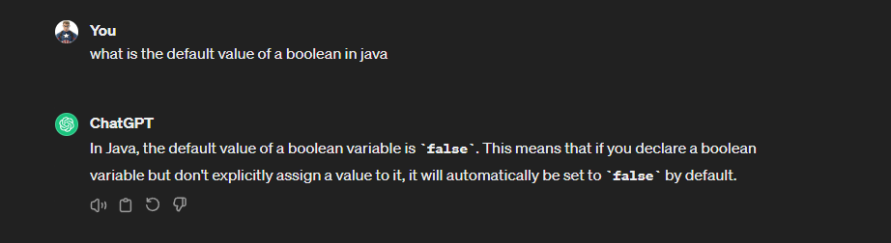OpenAI. (2024). What is the default value of a boolean in Java.

‌

‌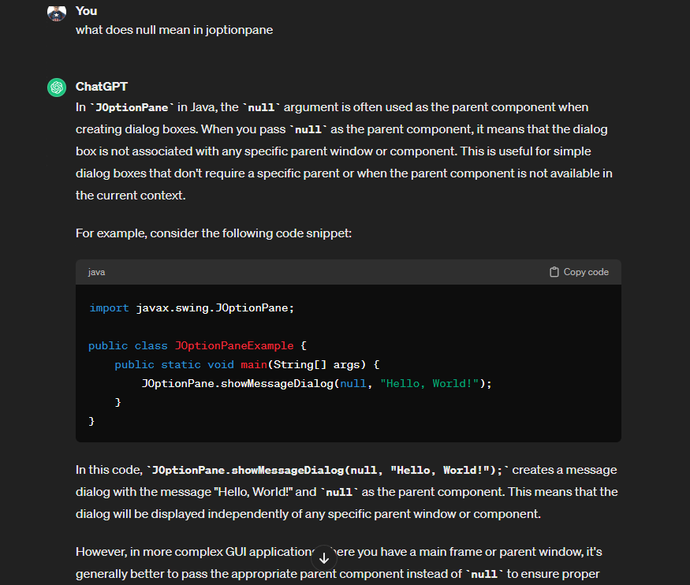

OpenAI. (2024). What does null mean in JOptionPane.

OpenAI. (2024). How to avoid infinite loops when using while in Java.